|  |  |  |  |  |  |  |  |  |  |
| --- | --- | --- | --- | --- | --- | --- | --- | --- | --- |
| **SCHOOL OF COMPUTER SCIENCE AND ARTIFICIAL INTELLIGENCE** | | | | | **DEPARTMENT OF COMPUTER SCIENCE ENGINEERING** | | | | |
| **Program Name:** B. Tech | | | | **Assignment Type: Lab** | | | **Academic Year:**2025-2026 | | |
| **Course Coordinator Name** | | | | Venkataramana Veeramsetty | | | | | |
| **Instructor(s) Name** | | | | |  | | --- | | Dr. V. Venkataramana (Co-ordinator) | | Dr. T. Sampath Kumar | | Dr. Pramoda Patro | | Dr. Brij Kishor Tiwari | | Dr.J.Ravichander | | Dr. Mohammand Ali Shaik | | Dr. Anirodh Kumar | | Mr. S.Naresh Kumar | | Dr. RAJESH VELPULA | | Mr. Kundhan Kumar | | Ms. Ch.Rajitha | | Mr. M Prakash | | Mr. B.Raju | | Intern 1 (Dharma teja) | | Intern 2 (Sai Prasad) | | Intern 3 (Sowmya) | | NS_2 ( Mounika) | | | | | | |
| **Course Code** | | | 24CS002PC215 | **Course Title** | | AI Assisted Coding | | | |
| **Year/Sem** | | | II/I | **Regulation** | | R24 | | | |
| **Date and Day**  **of Assignment** | | | Week7 - Monday | **Time(s)** | |  | | | |
| **Duration** | | | 2 Hours | **Applicable to**  **Batches** | |  | | | |
| **AssignmentNumber:14.1**(Present assignment number)/**24**(Total number of assignments) | | | | | | | | | |
|  | | | | | | | | | |
|  | **Q.No.** | **Question** | | | | | | ***Expected Time***  ***to complete*** |  |
|  | 1 | **Lab 14: Web Design Application – AI-Assisted HTML/CSS/JS Generation**  **Lab Objectives**   * Design **functional, visually appealing** web applications using HTML, CSS, and JavaScript with AI assistance. * Apply **responsive, accessible, and interactive design principles**. * Create **practical UI components** for real-world web applications. * Use AI to optimize **layout, UX, and performance**.   **Task 1 – Portfolio Website Design**  You are building a personal portfolio website to showcase your work.  **Requirements:**   * Create sections for **About Me**, **Projects**, and **Contact**. * Use AI to:   + Suggest **color palettes** and typography.   + Create a **responsive layout** with Grid/Flexbox.   + Add smooth scrolling navigation.   **Task 2 – Online Store Product Page**  Design a product display page for an online store.  **Requirements:**   * Display product image, title, price, and "Add to Cart" button. * Use AI to:   + Style with **BEM methodology**.   + Make layout **responsive**.   + Add **hover effects** and **"Add to Cart" alert**.   **Task 3 – Event Registration Form**  Build an event registration form for a conference.  **Requirements:**   * Collect **name, email, phone number, and session selection**. * Use AI to:   + Add **form validation** with JavaScript.   + Make the form **accessible** with labels and ARIA.   + Style with a **professional look**.   **Task Description #4 (Data – Fetch API & Render List with Loading/Error States)**   * **Task:** Fetch JSON from an API and render items to the DOM with loading and error UI. * **Instructions:**   + Ask AI to write fetch() logic, create DOM nodes safely, and add skeleton/loading text.   ✅ Deliverables (For All Tasks)   1. AI-generated prompts for code and test case generation. 2. At least 3 assert test cases for each task. 3. AI-generated initial code and execution screenshots. 4. Analysis of whether code passes all tests. 5. Improved final version with inline comments and explanation. 6. Compiled report (Word/PDF) with prompts, test cases, assertions, code, and output.   Top of Form | | | | | | Week7 - Monday |  |

**Task 1 – Portfolio Website Design**

You are building a personal portfolio website to showcase your work.

**Requirements:**

* Create sections for **About Me**, **Projects**, and **Contact**.
* Use AI to:
  + Suggest **color palettes** and typography.
  + Create a **responsive layout** with Grid/Flexbox.
  + Add smooth scrolling navigation.

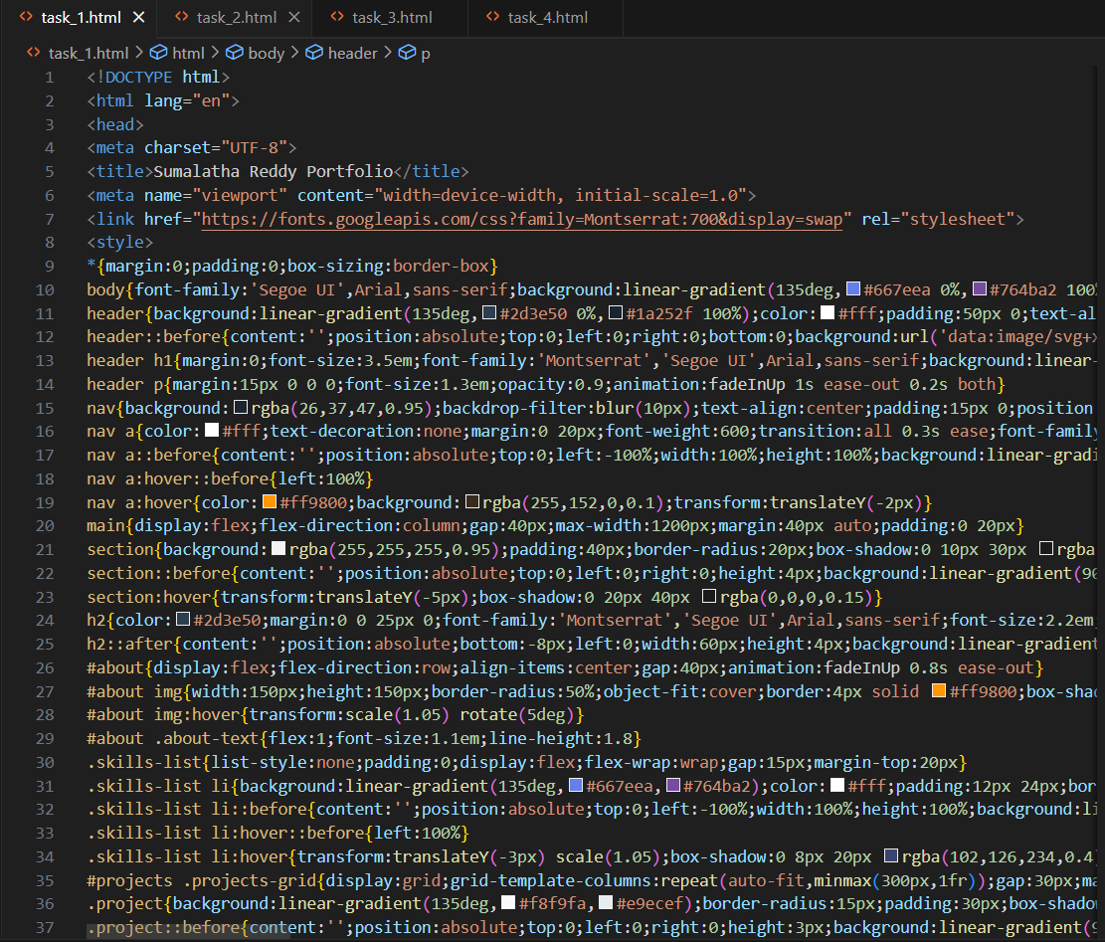

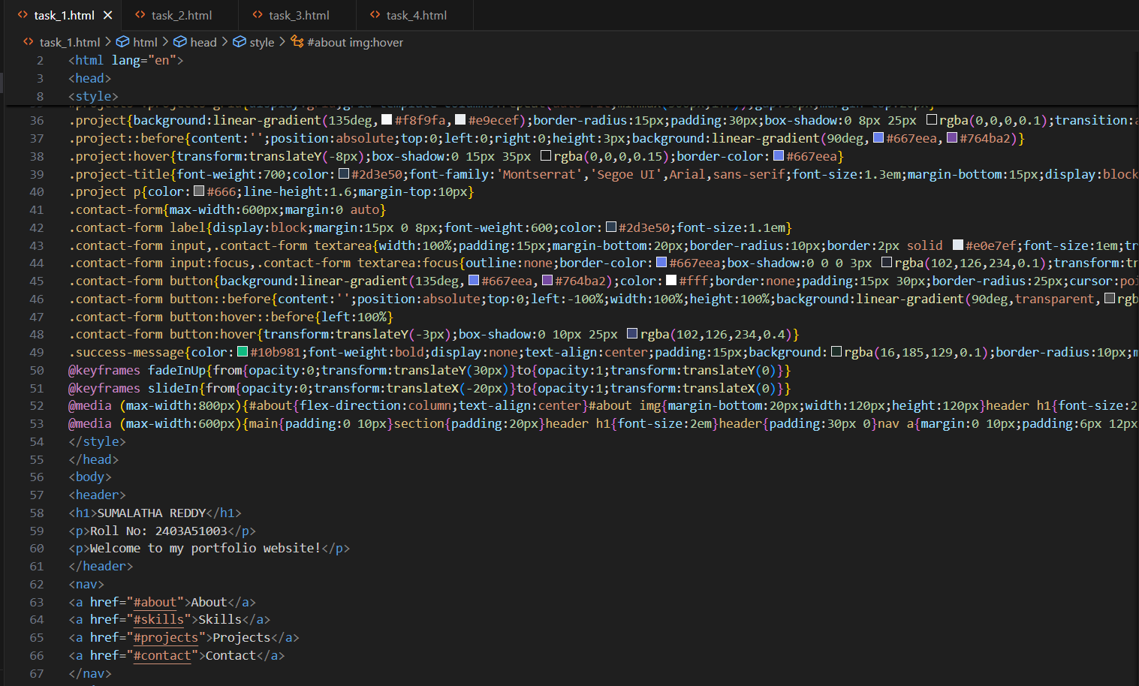

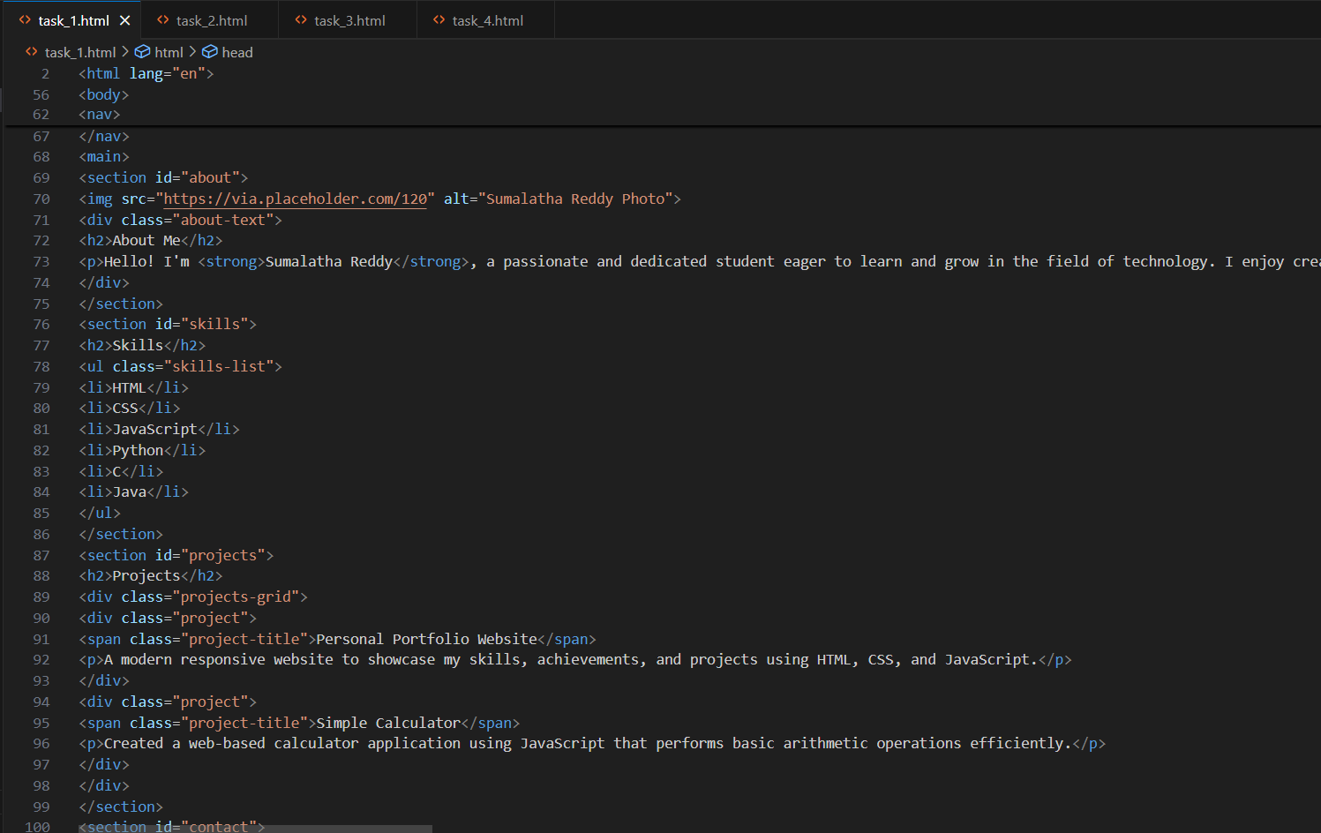

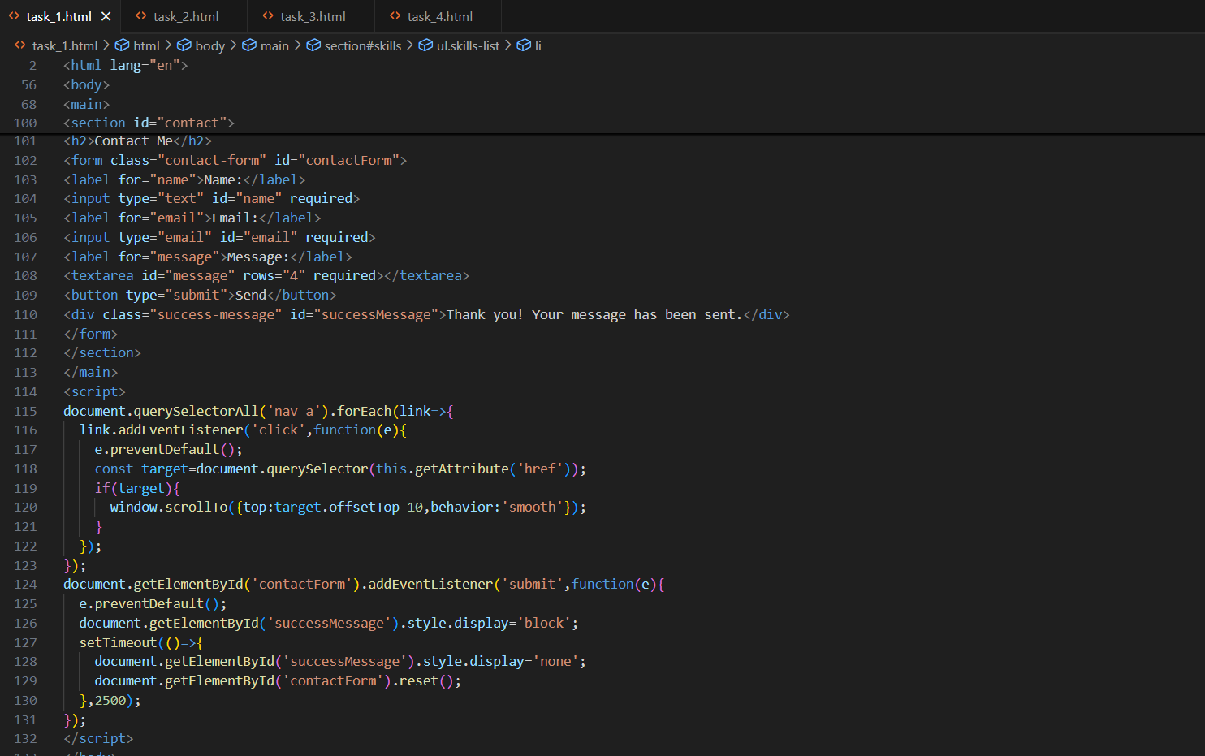

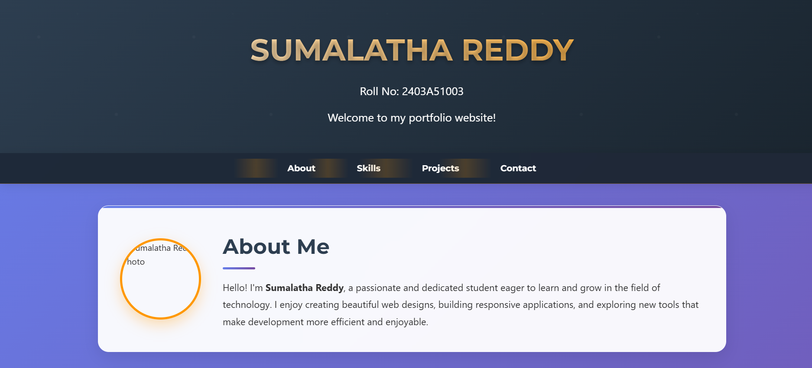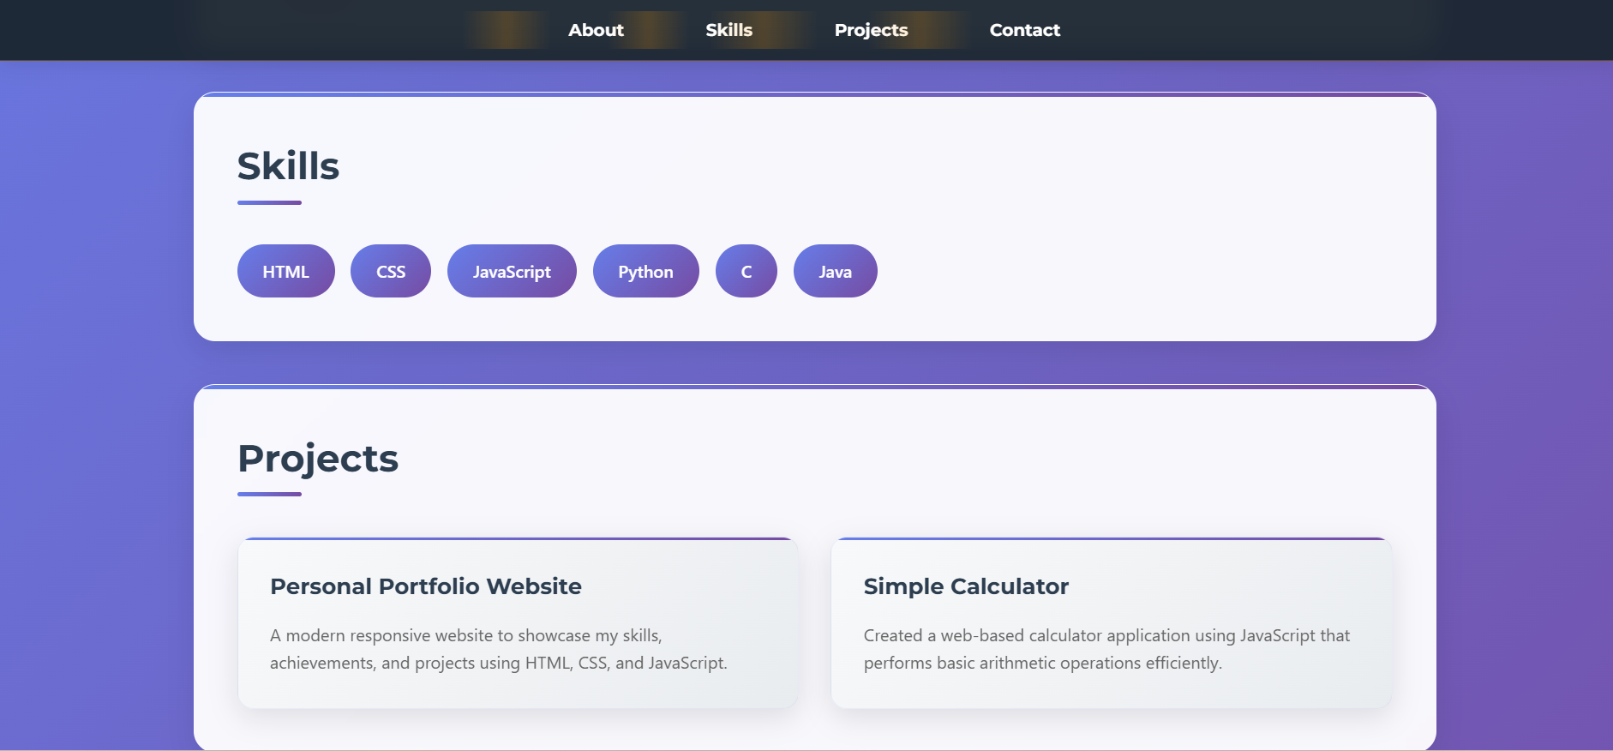

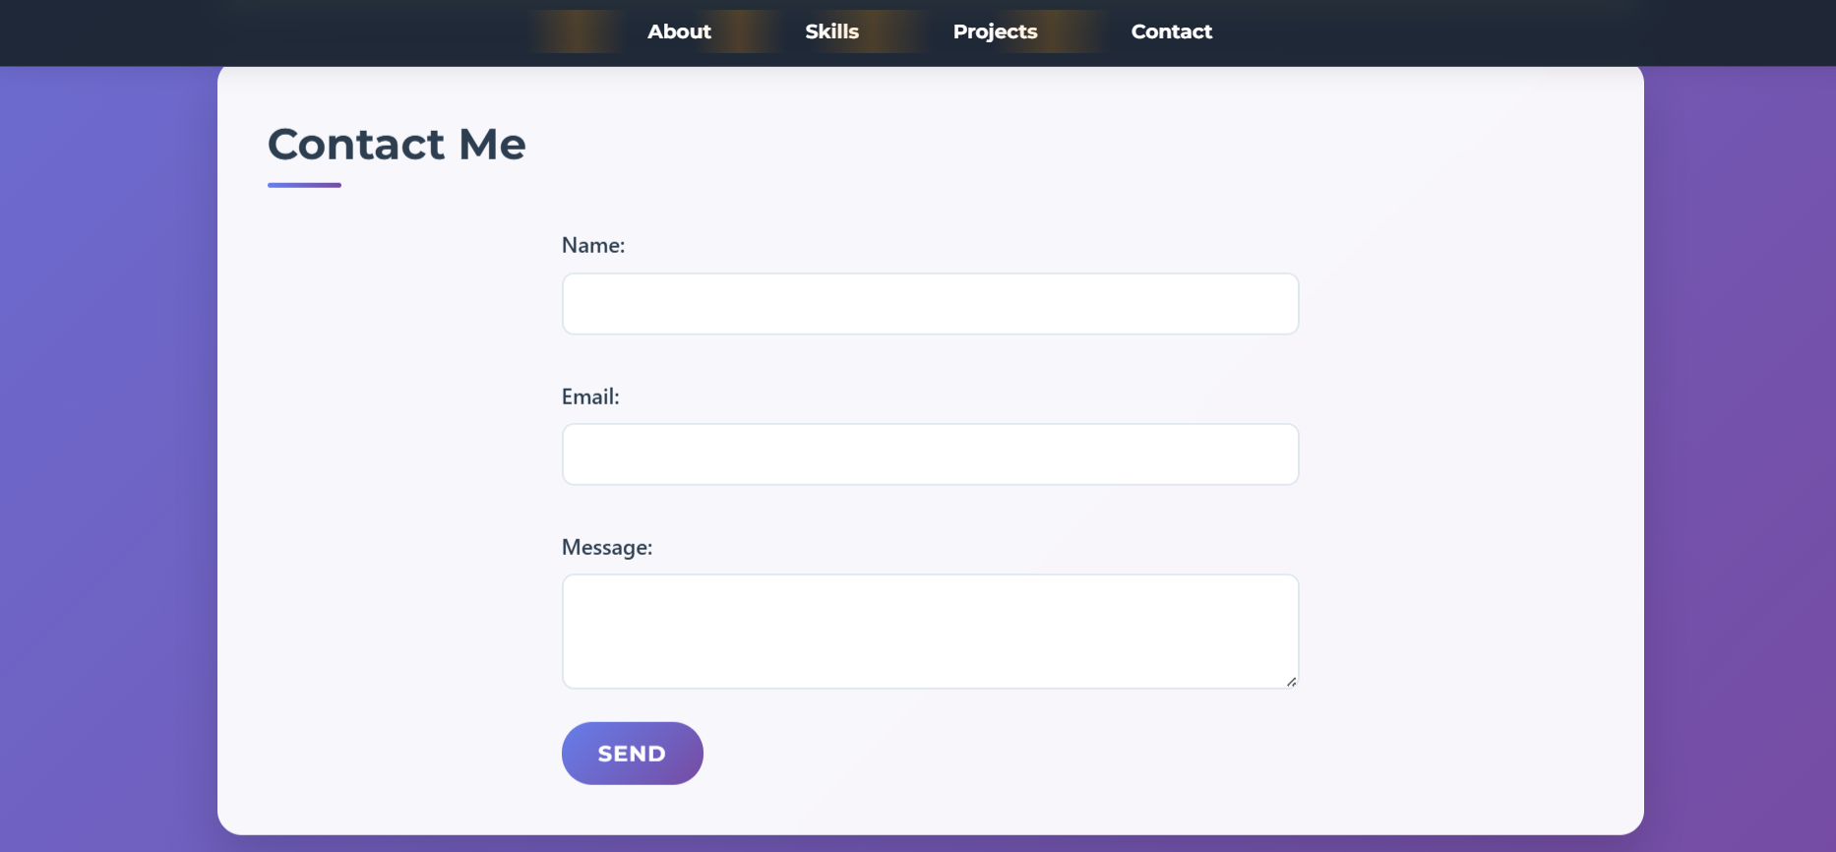

**Task 2 – Online Store Product Page**

Design a product display page for an online store.

**Requirements:**

* Display product image, title, price, and "Add to Cart" button.
* Use AI to:
  + Style with **BEM methodology**.
  + Make layout **responsive**.
  + Add **hover effects** and **"Add to Cart" alert**.

**Task 3 – Event Registration Form**

Build an event registration form for a conference.

**Requirements:**

* Collect **name, email, phone number, and session selection**.
* Use AI to:
  + Add **form validation** with JavaScript.
  + Make the form **accessible** with labels and ARIA.
  + Style with a **professional look**.

**Task Description #4**

**(Data – Fetch API & Render List with Loading/Error States)**

* **Task:** Fetch JSON from an API and render items to the DOM with loading and error UI.
* **Instructions:**
  + Ask AI to write fetch() logic, create DOM nodes safely, and add skeleton/loading

text.

